

**Insert School Logo**

**Semester One Examination 2019**

**Question/Answer Booklet**

**MATHEMATICS**

**METHODS UNIT 3**

**Section One:**

**Calculator–free**

|  |
| --- |
| Student Name: _____________________________________ |
| Teacher‘s Name: _____________________________________ |
|  |

**Time allowed for this section**

Reading time before commencing work: five minutes

Working time for paper: fifty minutes

**Material required/recommended for this section**

**To be provided by the supervisor**

This Question/Answer booklet

Formula Sheet

**To be provided by the candidate**

Standard items: pens(blue/black preferred), pencils(including coloured), sharpener, correction tape/fluid, erasers, ruler, highlighters

Special Items: nil

**Important note to candidates**

No other items may be taken into the examination room. It is **your** responsibility to ensure that you do not have any unauthorised notes or other items of a non–personal nature in the examination room. If you have any unauthorised material with you, hand it to the supervisor **before** reading any further.

**Structure of this paper**

|  |  |  |  |  |  |
| --- | --- | --- | --- | --- | --- |
|  | Number of questions available | Number of questions to be attempted | Working time (minutes) | Marks available | Percentage of exam |
| **Section One**  **Calculator—free** | **9** | **9** | **50** | **50** | **35** |
| Section Two  Calculator—assumed | 15 | 15 | 100 | 100 | 65 |
|  | | | |  | 100 |

**Instructions to candidates**

1. The rules for the conduct of Western Australian external examinations are detailed in the *Year 12 Information Handbook 2019.* Sitting this examination implies that you agree to abide by these rules.
2. Answer the questions according to the following instructions.

Section One: Write answers in this Question/Answer Booklet. Answer **all** questions.

**Show all your working clearly.** Your working should be in sufficient detail to allow your

answers to be checked readily and for marks to be awarded for reasoning. Incorrect

answers given without supporting reasoning cannot be allocated any marks. For any

question or part question worth more than two marks, valid working or justification is

required to receive full marks. If you repeat an answer to any question, ensure that you

cancel the answer you do not wish to have marked.

It is recommended that you **do not use pencil**, except in diagrams.

1. You must be careful to confine your responses to the specific questions asked and to follow any instructions that are specific to a particular question.
2. Spare pages are included at the end of this booklet. They can be used for planning your responses and/or as additional space if required to continue an answer.

* Planning: If you use the spare pages for planning, indicate this clearly at the top of the

page.

* Continuing an answer: If you need to use the space to continue an answer, indicate in the original answer space where the answer is continued, i.e. give the page number. Fill in the number of the question that you are continuing to answer at the top of the page.

1. The Formula Sheet is **not** handed in with your Question/Answer Booklet.

# Section One: Calculator–free 50 marks

This section has **nine (9)** questions. Attempt **all** questions. Write your answers in the spaces provided.

Spare pages are included at the end of this booklet. They can be used for planning your responses and/or as additional space if required to continue an answer.

* Planning: If you use the spare pages for planning, indicate this clearly at the top of the page.
* Continuing an answer: If you need to use the space to continue an answer, indicate in the original answer space where the answer is continued, i.e. give the page number. Fill in the number of the question(s) that you are continuing to answer at the top of the page.

Working time: 50 minutes

**Question 1 (3 marks)**

Given the function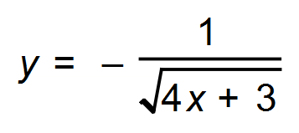 then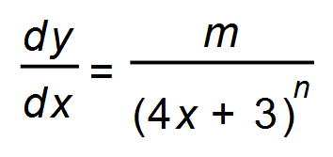

(a) State the values of *m* and *n* respectively. (2)

(b) Determine the instantaneous rate of change of y when x = 1.5 (1)

**Question 2 (11 marks)**

Consider the function 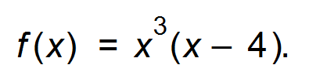

(a) State the coordinates of the stationary points. (3)

(b) Apply the second derivative test to determine the nature of those stationary points. (4)

(c) (i) Show that an oblique point of inflection exists at *x* = 2. (2)

(ii) Find the equation of the tangent at *x* = 2. (2)

**Question 3 (4 marks)**

Differentiate the following. (Solutions should have positive indices where appropriate.)

(a) 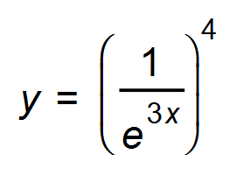 (2)

(b) 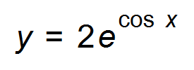 (2)

**Question 4 (5 marks)**

The distribution function of a certain random variable *X* is given by:

*f* (*x*) = 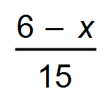 where *x* = 1, 2, 3, 4, 5.

(a) Show that a probability distribution is formed by the values of *f* (*x*). (2)

(b) What is the probability of obtaining a value less than 3? (1)

(c) Determine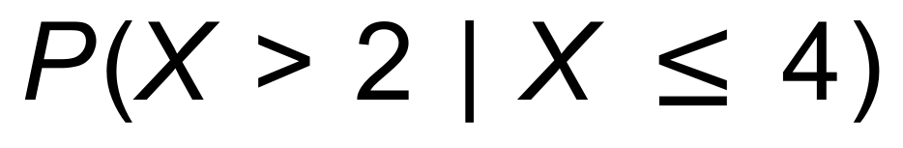. (2)

**Question 5 (3 marks)**

Mani is working with a function, *g*, which passes through the point (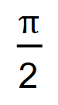, 1).

She differentiates the function and finds that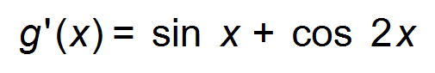. Determine the primitive function. (3)

**Question 6 (4 marks)**

Use Calculus rules to find the gradient functions of the following. (Do not simplify.)

(a) 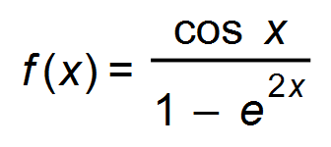 (2)

(b) 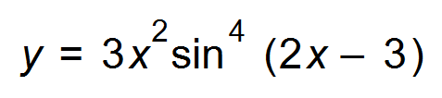 (2)

**Question 7 (8 marks)**

(a) Given that 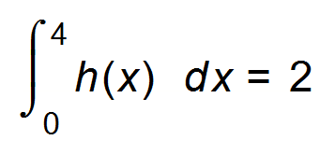and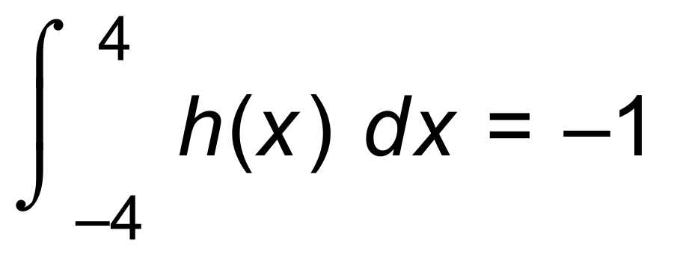, calculate:

(i) 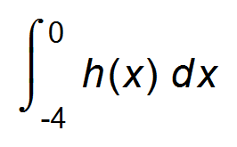 (1)

(ii) 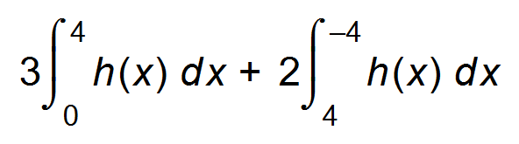 (2)

(iii) the area bounded by the curve *h*(*x*) and the *x* – axis, between *x* = −4 and *x* = 4.

(2)

(b) Find *x* in terms of *t*, given that 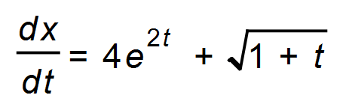 and 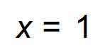 when 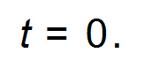 (3)

**Question 8 (7 marks)**

(a) The discrete random variable *X* takes the values of 0, 1 and 2 only. The probability distribution of *X* is shown in the table, where *p* is a constant and 0 < *p* <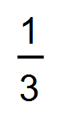.

|  |  |  |  |
| --- | --- | --- | --- |
| *x* | 0 | 1 | 2 |
| *P(X = x)* |  |  | *p* |

Given that Var(*X*) = 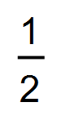 find the two possible values of E(*X*). (4)

(b) A discrete random variable *Y* has an expected value of 12 and a variance of 9.

Find:

(i) E(2*Y $-$*3) (1)

(ii) Standard deviation(2*Y $-$*3) (2)

**Question 9 (5 marks)**

(a) Evaluate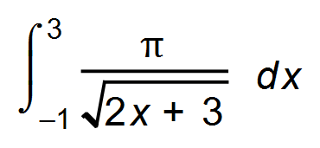 (2)

(b) A digital beetle has been programmed such that its position is given by the equation

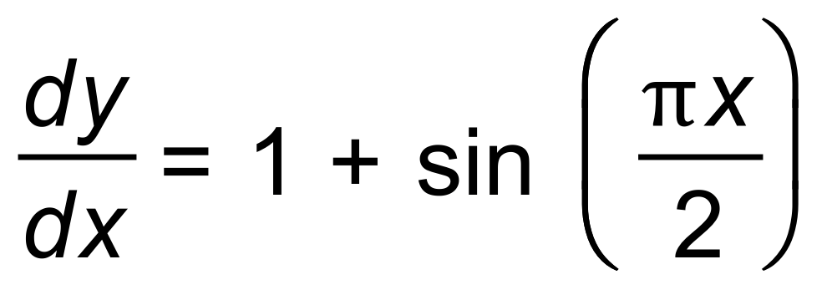.

The beetle changes its direction as the value of 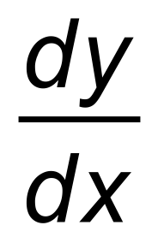 changes.

         If it is at the point (1, 4), find the equation of the path it travels.                                        (3)

**End of Section One**

**Additional working space**

Question number(s): ……………………

**Additional working space**

Question number(s): ……………………

WATP acknowledges the permission of the School Curriculum and Assessment Authority in providing instructions to students.